**Weekly Report 11/11**

**MSiA-400 Group 1** : Ellen, Henry, Ishu, Enzo

Tasks Accomplished:

* After the discussion during our weekly meeting, we decided to change our previous business question (Store Clustering) to Product Clustering.

--- Product clustering: Cluster with product-specific information (color, brand, etc) in order determine which products to recommend based on a purchase of 1 product with the same characteristics

* Looked into the potential parameters/features for our future models and assigned tasks to each member as shown below

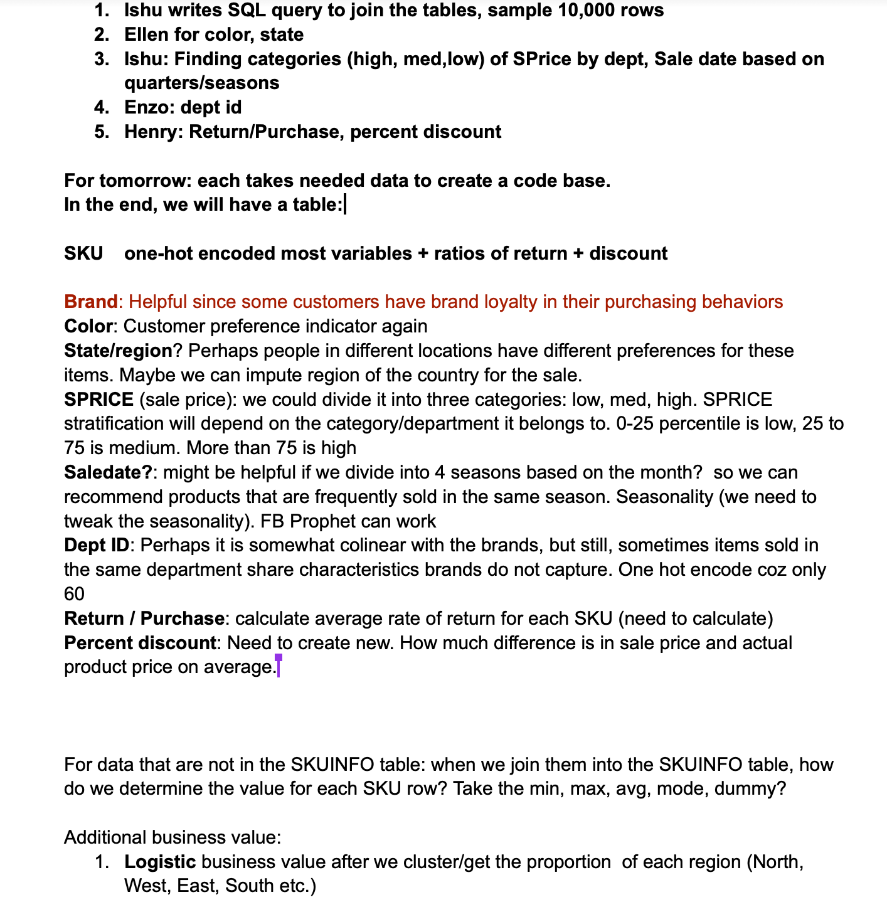

* Finished assigned coding and pushed to Github. (Please see code in Github)

Plans for Next Week:

1. Modify data cleanning process based on the new business question.
2. Join and combine the tables into one for further model building.
3. Look for different machine learning models that could be applied to the business question and think about how we define a better model in this project.
4. Continue feature engineering work for colors, explore state and regions.